Aldev Smara Dahana Suryabudhi Rahardjo

A11.2020.12880

**REPOSITORY MINGGU PERTAMA**

1.

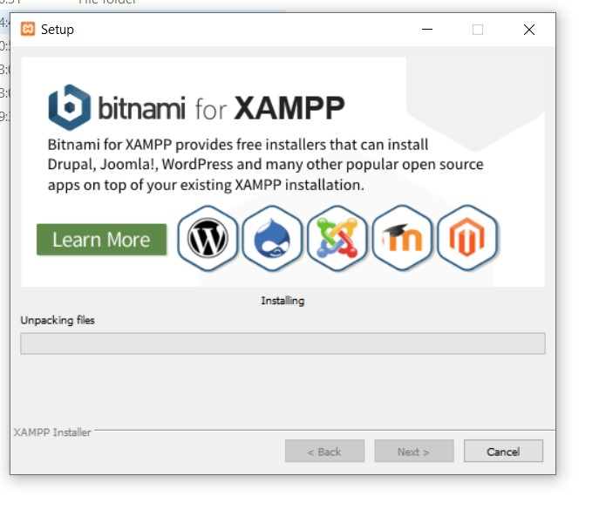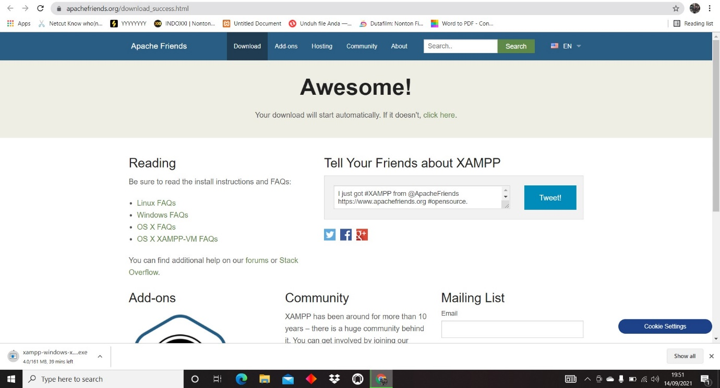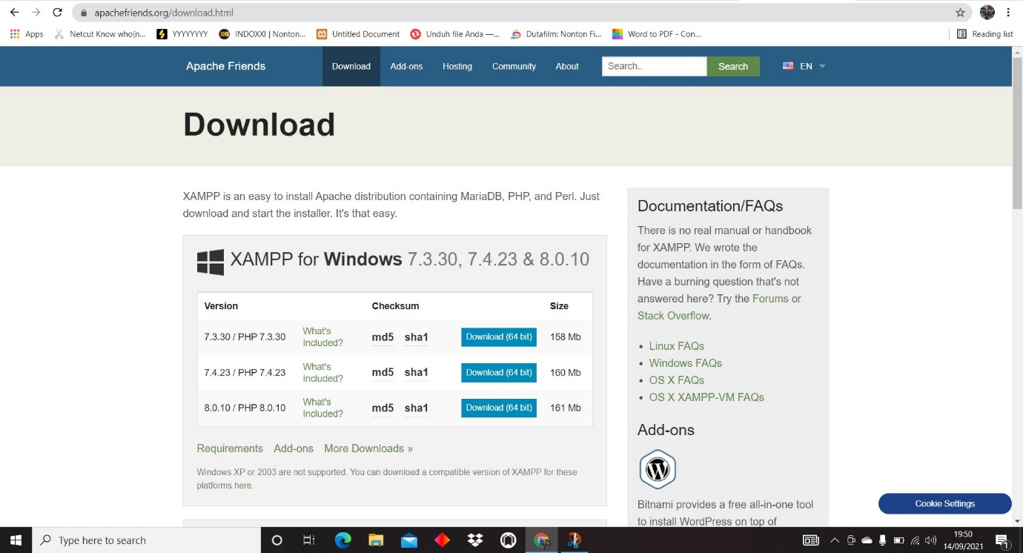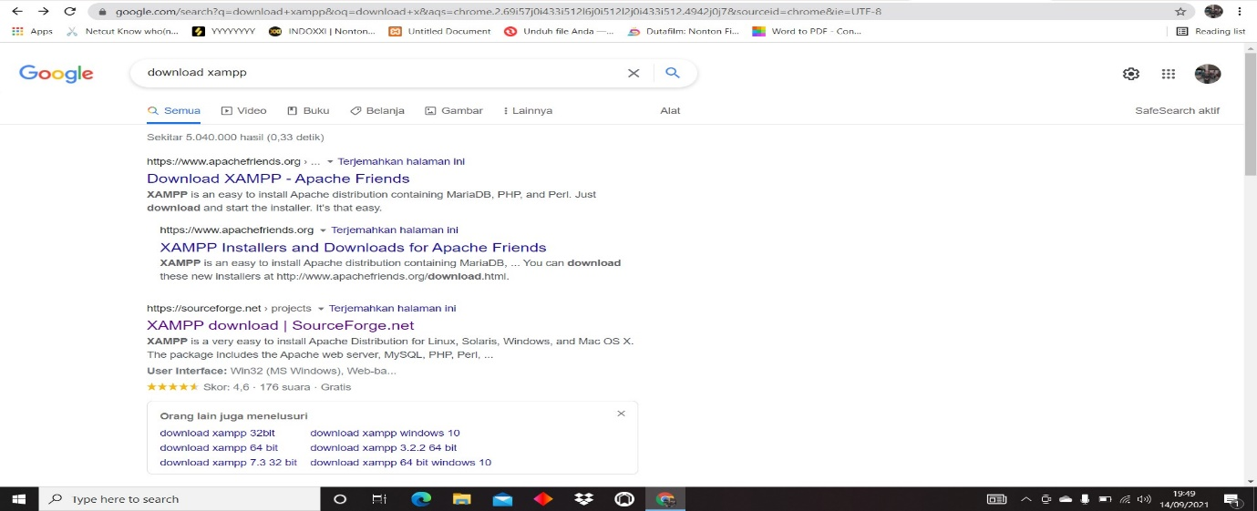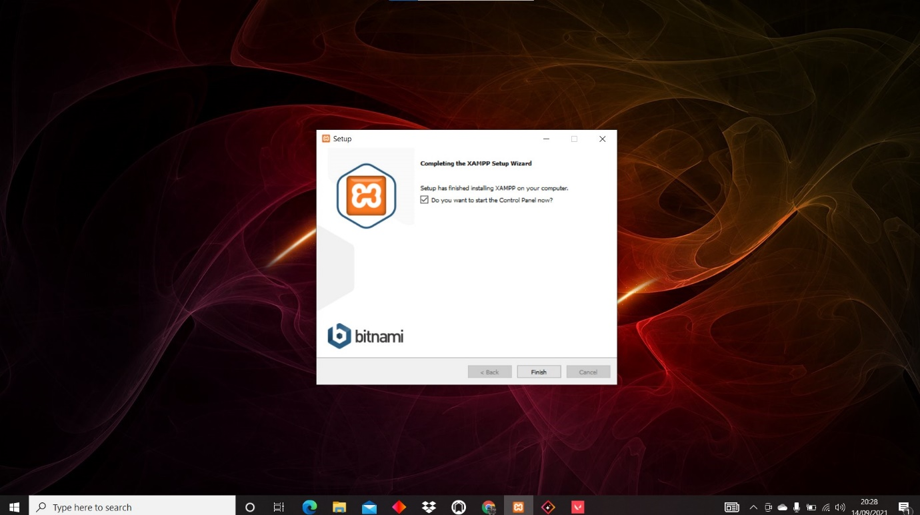

2. <https://github.com/SoS1ckkk/webdas>

**REPOSITORY MINGGU KEDUA**